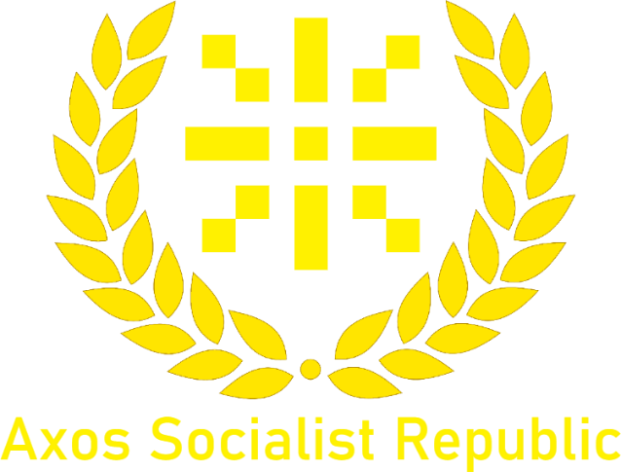

Hillside Agreement Conclusion
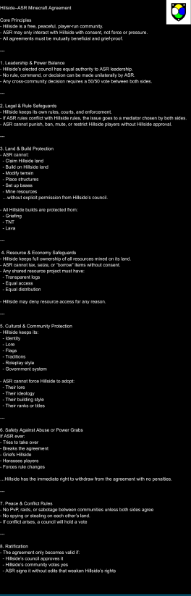
On 15th of January 2026 a letter came back from the Leader of Hillside disapproving the agreement that had been put forward. Below are the contents of the conclusions that have been reached:
As seen in the letter, Hillside wishes to remain fully independent from the Axos Socialist Republic and its state-members. The Axos Socialist Republic will follow the terms outlined in the current agreement and not attempt any further diplomatic relations with Hillside until further notice.
The representative who accepted the terms of the original agreement on behalf of Hillside is expected to no longer make decisions on behalf of their representing nation. All future representatives of nations will not be allowed to make decisions without direct agreement from both the nation’s leader and the ASR’s leader.
The Lord has also made a reply to the Hillside council following their letter, it is on the next page:

“To, Hillside Council
I have received your letter about leaving the ASR, and I understand your reservations. In future representatives will not be making decisions without consent from the leaders of the nation they are representing. We will also be tweaking future terms regarding land rights and legal rights. I’m not sure about the validity of this but the representative claimed the Hillside Council had called me a dictator due to documents referring to me as “the Lord”, this is my title, I have used it for years going further back than the AXU. This is not a glorification of myself. I’m not an arrogant fool. It’s just a title, nothing more. I’d also like to note we are a communist dictatorship, yet I’m not the only leader. My people are happy with me as a leader, and I am happy with them as my people. I also don’t know much about your leadership system, but I’ve only heard about only one leader and nothing about an election. That’s all I have to say. Make up your own mind about our leadership and how socialist we really are. I know this isn’t the end, and I’m certain we will cross paths again many more times. Good luck with your country,
Axo*”
The Axos Socialist Republic also retains the following rights:
- All members of the Axos Socialist Republic may visit Hillside and interact with its inhabitants.
- The Axos Socialist Republic may freely trade with Hillside, and its members.
- The Axos Socialist Republic may only build 3 hectometres from Hillside borders without permission, including all regions.
By The Sentry 16th of January 2026

